EV Market Analysis Dashboards
Project documentation: Electric Vehicle Market Performance & Insights (Tableau)
Prepared by Hussain Saifee
Tool | Tableau (workbook: EV Market Analysis)
Data source | ev_market_train
Dashboards | - Electric Vehicle Market Analysis Dashboard (Scenarios 1 and 3)  - Manufacturer Competitive Analysis (Scenario 2)
Date | 24 October 2026

Purpose
This workbook answers the three scenarios of the module with two interactive dashboards built on the same
EV market data. The Electric Vehicle Market Analysis Dashboard serves the market strategy view (Scenario 1) and the sustainability research view (Scenario 3): what sells, how batteries compare, how far vehicles can drive and how customers rate each category. The Manufacturer Competitive Analysis dashboard serves the business intelligence view (Scenario 2): who leads, how they are rated and where vehicles are built.

Dashboard screenshots
Dashboard 1: Electric Vehicle Market Analysis Dashboard
Insert a screenshot of Dashboard 1 here (Ta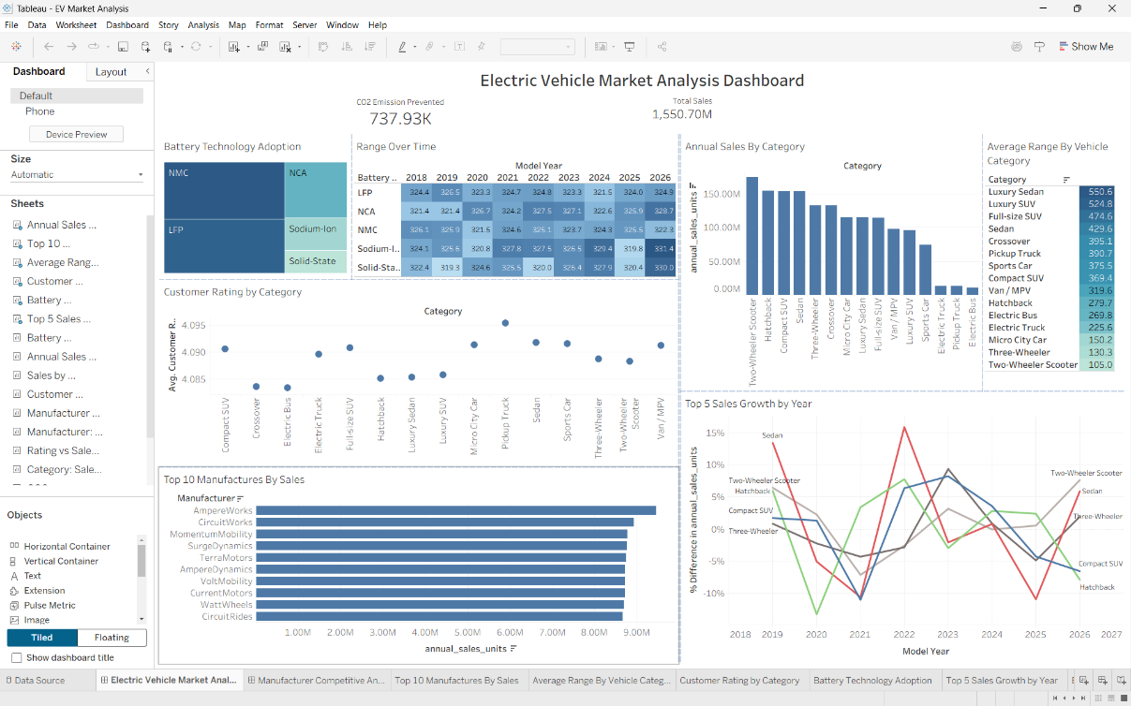
Dashboard 2: Manufacturer Competitive Analysis
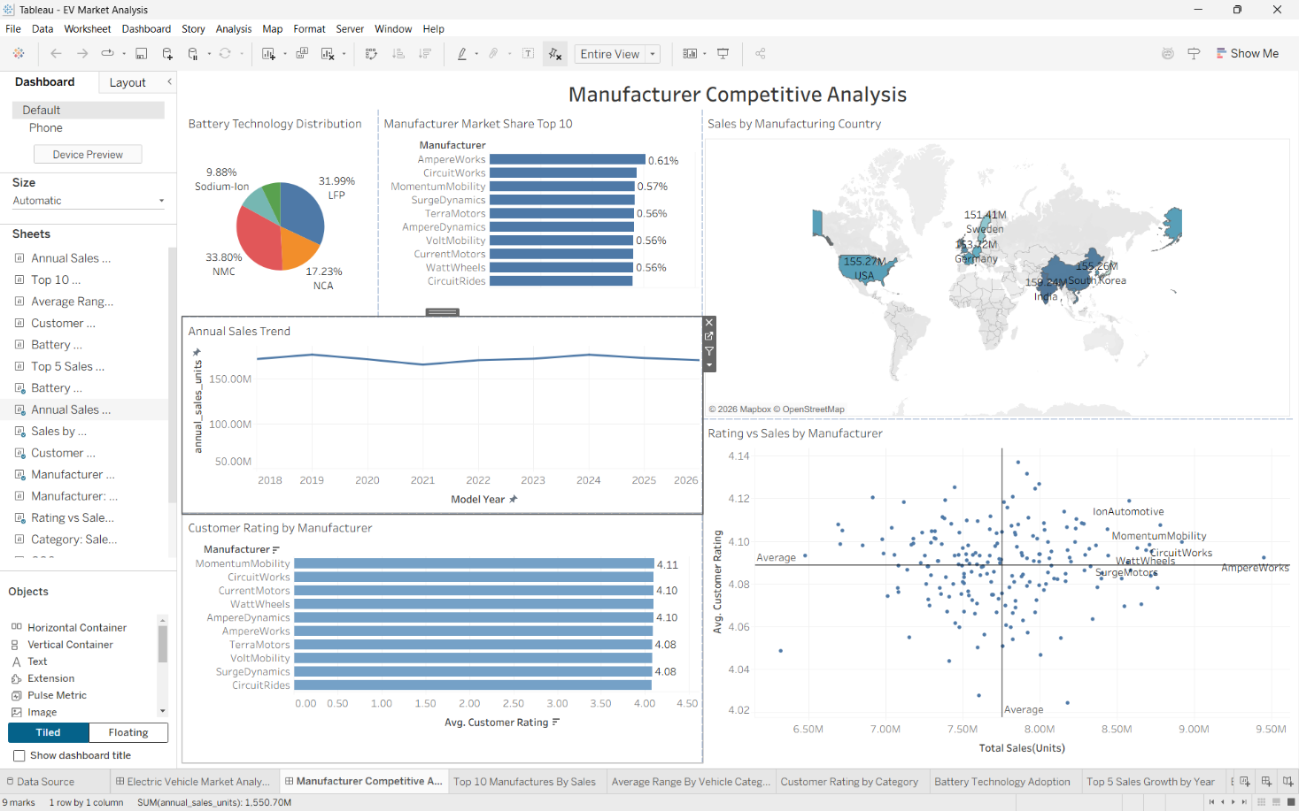

Scenarios and requirements
Each requirement from the scenarios is answered by at least one visual. D1 means Dashboard 1 (Electric Vehicle Market Analysis Dashboard) and D2 means Dashboard 2 (Manufacturer Competitive Analysis).
Scenario | What the user needs | Where it is answered
1. Emily Johnson  EV Market Strategy  Director | Which vehicle categories contribute most to annual sales; the leading manufacturers; customer satisfaction by segment; battery technology adoption; driving range by category; high-growth segments; performance across regions. | D1: Annual Sales by Category; Customer Rating by Category; Top 10 Manufacturers by Sales; Battery Technology Adoption; Average Range by Vehicle Category; Top 5 Sales Growth by Year; Market Region filter.
2. David Chen  Automotive BI Manager | Manufacturer market share; annual sales performance; battery technology distribution; manufacturing country analysis; customer ratings; competitive advantages among manufacturers. | D2: Manufacturer Market Share Top 10;  Annual Sales Trend; Battery Technology  Distribution; Sales by Manufacturing Country; Customer Rating by Manufacturer; Rating vs Sales by Manufacturer.
3. Dr. Sarah Williams  Sustainable Mobility  Research Analyst | Compare battery technologies; driving range improvements; global manufacturing distribution; customer satisfaction across categories; technology trends and carbon reduction. | D1: Battery Technology Adoption; Range Over Time (heat map by battery type and year); Average Range by Vehicle Category; Customer Rating by Category; CO2 Emission Prevented KPI.  D2: Sales by Manufacturing Country (global manufacturing distribution).

Data and key fields
Both dashboards use one table, ev_market_train. These are the fields they rely on.
Field | Used for
annual_sales_units | Sales volume (summed); drives market share, trends, category and country totals
Category | Vehicle segment (for example Sedan, Luxury SUV, Two-Wheeler Scooter, Electric Bus)
Manufacturer | Market share, ratings and the scatter plot (about 200 manufacturers)
Manufacturing Country | Where vehicles are built (map)
Market Region | Where vehicles are sold; the dashboard filter (seven regions)
Model Year | Time axis, 2018 to 2026
Battery Type | LFP, NCA, NMC, Sodium-Ion and Solid-State
Range Km | Driving range (averaged)
Customer Rating | Satisfaction score (averaged, never summed)
Co2 Saved Tons Per Year | CO2 emission prevented KPI

Dashboard 1: Electric Vehicle Market Analysis Dashboard
Scenarios 1 and 3: market performance, batteries, range and customer satisfaction.

Top strip
- Total Sales KPI: 1,550.70M units across the dataset.
- CO2 Emission Prevented KPI: 737.93K tons.
- Market Region filter: Africa, Asia Pacific, Europe, Latin America, Middle East, North America and South Asia. Set to apply to all worksheets that use the data source.

Charts
Chart | Type | Built from | What it shows
Battery Technology  Adoption | Treemap | Battery Type;  SUM(annual_sales_units) | Sales by battery type; box size is sales.
Range Over Time | Heat map | Battery Type by Model Year;  AVG(Range Km) as color and label | Average range per battery type in each year, with the km value in every cell.
Annual Sales by  Category | Vertical bar | Category; SUM(annual_sales_units) | Sales volume of each vehicle category.
Customer Rating by  Category | Dot plot | Category; AVG(Customer Rating) | Average rating of each category; the axis is zoomed to about 4.085 to 4.095.
Average Range by  Vehicle Category | Highlight table | Category; AVG(Range Km) | Average driving range for each category.
Top 10 Manufacturers by  Sales | Horizontal bar | Manufacturer (Top 10 by  SUM(annual_sales_units)) | Units sold by the ten biggest manufacturers.
Top 5 Sales Growth by  Year | Line | Model Year; year-over-year % difference in  SUM(annual_sales_units); top 5 categories by sales | Whether the biggest categories are growing.

Dashboard 2: Manufacturer Competitive Analysis
Scenario 2: manufacturer performance, ratings and manufacturing geography.
Chart | Type | Built from | What it shows
Manufacturer Market  Share Top 10 | Horizontal bar | Top 10 manufacturers by sales; market share % | Each leading manufacturer's share of total units.
Customer Rating by  Manufacturer | Bar | Same Top 10; AVG(Customer  Rating) | Average rating of the leading manufacturers, labeled to two decimals.
Annual Sales Trend | Line | Model Year;  SUM(annual_sales_units) | Total sales per year, 2018 to 2026.
Battery Technology  Distribution | Pie | Battery Type;  SUM(annual_sales_units) as angle | Share of sales by battery type.
Sales by Manufacturing  Country | Filled map | Manufacturing Country;  SUM(annual_sales_units) | Where vehicles are built and how much each country produces.
Chart | Type | Built from | What it shows
Rating vs Sales by  Manufacturer | Scatter with average lines | SUM(annual_sales_units) vs AVG(Customer Rating), one dot per manufacturer | Whether higher sales go with higher ratings; the lines split the chart into four quadrants.

Market share calculation
Market share is each manufacturer's units divided by the whole market's units, so the Top 10 filter does not change the denominator:
market share % = SUM([annual_sales_units]) / MIN({ FIXED : SUM([annual_sales_units]) })

Key insights
Fragmented market (D2). About 200 manufacturers share the market and none dominates. The ten biggest each hold roughly 0.56% to 0.61% of total units, led by AmpereWorks at about 0.61%.
Battery mix (D1, D2). NMC (33.80%) and LFP (31.99%) together account for about 66% of sales. NCA follows at 17.23%, then Sodium-Ion at 9.88% and Solid-State at 7.10%.
Sales are steady, not surging (D2). Annual sales stay between about 166M and 177M units from 2018 to 2026, with peaks in 2019 and 2024 and a dip in 2021. There is no strong upward trend in the data.
No steady growth segment (D1). Year-over-year sales changes for the five biggest categories
(Two-Wheeler Scooter, Hatchback, Compact SUV, Sedan and Three-Wheeler) swing between roughly -13% and +16%, and none grows steadily.
Category leaders (D1). Two-Wheeler Scooter, Hatchback, Compact SUV and Sedan sell the most units. Electric Truck, Pickup Truck and Electric Bus sell the least.
Range depends on the vehicle, not the year (D1). Luxury Sedan has the highest average range (550.6 km) and Two-Wheeler Scooter the lowest (105.0 km). The heat map shows every battery type at about 319 to 331 km in every year. Sodium-Ion (331.4 km) and Solid-State (330.0 km) are highest in 2026, but Sodium-Ion was at 319.8 km in 2025, so one year is not a trend.
Manufacturing is evenly spread (D2). Production per country falls in a narrow band of about 148M to 159M units. India is highest at 159.24M, then China (158.51M), USA (155.27M), South Korea (155.26M), Germany (153.72M) and Sweden (151.41M).
Ratings barely differ (D1, D2). Category averages sit around 4.09 and the Top 10 manufacturers range from 4.07 to 4.11. Customer rating does not separate winners from losers; sales volume does.
Volume, not rating, drives advantage (D2). In the scatter plot there is no clear link between sales and rating. AmpereWorks sells the most (about 9.5M units) with a rating close to the average.

Design decisions
- Two dashboards by audience. Dashboard 1 covers market strategy and sustainability research, and Dashboard 2 covers manufacturer competition. This keeps each page readable instead of crowding all scenarios onto one.
- Averages, not sums, for ratings and range. Summing ratings produces meaningless numbers, so every rating and range measure is an average.
- Honest axes. Bar charts start at zero. Where a line chart does not, the axis start is stated, so small changes are not made to look large.
- Zoomed rating axis. The category rating dot plot uses a narrow axis (about 4.085 to 4.095) because all values are close, so read the actual values rather than the dot positions.
- Heat map for range over time. Five battery types over nine years tangled as lines, so a heat map with the value in every cell replaced them.
- Market Region, not manufacturing country, for the filter. Market performance is about where vehicles are sold. Manufacturing country is shown separately on the map.

How to use the dashboards
- Switch between the two dashboards with the tabs at the bottom of the workbook.
- Pick one or more regions in the Market Region filter. The charts update.
- Hover over any bar, cell, dot, slice or country to see exact values in the tooltip.
- On the scatter plot, dots to the right of the vertical line sell more than the average manufacturer, and dots above the horizontal line are rated above average.

Limitations
- Customer ratings are very close together, so small differences should not be over-read.
- Range improvement by battery type is based on year-to-year averages, and a one-year rise is not a trend.
- Market share looks small because the market has about 200 manufacturers; it is accurate, not an error.
- Scenario 3's global manufacturing view (the map) is on Dashboard 2 and is shared with Scenario 2.
- The Top 10 manufacturers are ranked by total sales across the selected regions.

